

[*Open in app*](https://rsci.app.link/?%24canonical_url=https%3A%2F%2Fmedium.com%2Fp%2F47cafe2da69f&%7Efeature=LoOpenInAppButton&%7Echannel=ShowPostUnderUser&source=---two_column_layout_nav----------------------------------)

*Sign up* [*Sign In*](https://medium.com/m/signin?operation=login&redirect=https%3A%2F%2Fmedium.com%2F%40gaurishirkande11111%2Fhow-to-create-an-aws-ec2-instance-using-terraform-on-windows-47cafe2da69f&source=post_page---two_column_layout_nav-----------------------global_nav-----------)

***How to create an AWS EC2 instance using Terraform on Windows***



*Y NARESH BABU*

*4 min read · Mar 6*



[*Listen*](https://medium.com/m/signin?actionUrl=https%3A%2F%2Fmedium.com%2Fplans%3Fdimension%3Dpost_audio_button%26postId%3D47cafe2da69f&operation=register&redirect=https%3A%2F%2Fmedium.com%2F%40gaurishirkande11111%2Fhow-to-create-an-aws-ec2-instance-using-terraform-on-windows-47cafe2da69f&source=-----47cafe2da69f---------------------post_audio_button-----------)



*Share*



Terraform is an open-source infrastructure as a code tool that lets you build, change, and version cloud and on-prem resources safely and efficiently. It helps us manage and provision the infrastructure using a simple language which is Hashicorp Configuration Language. Terraform being cloud-agnostic can be used to automate the provisioning and managing of resources.

In this blog, we’ll see how to create an AWS EC2 Instance using Terraform. So let’s begin.

# Download Terraform on a Windows machine

Go to the official website of terraform: <https://www.terraform.io/>.

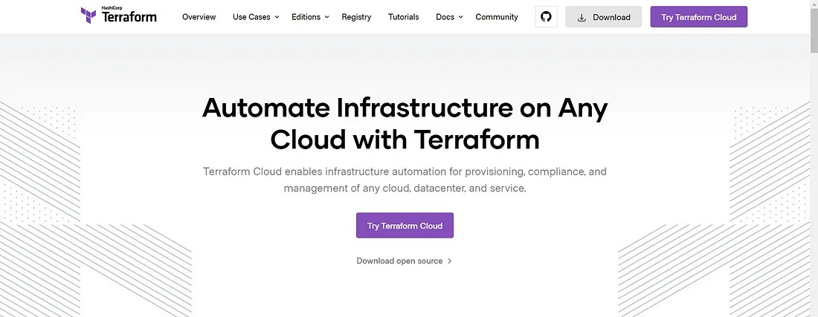

Click on Download and then select the Windows tab since we are downloading for a windows machine.

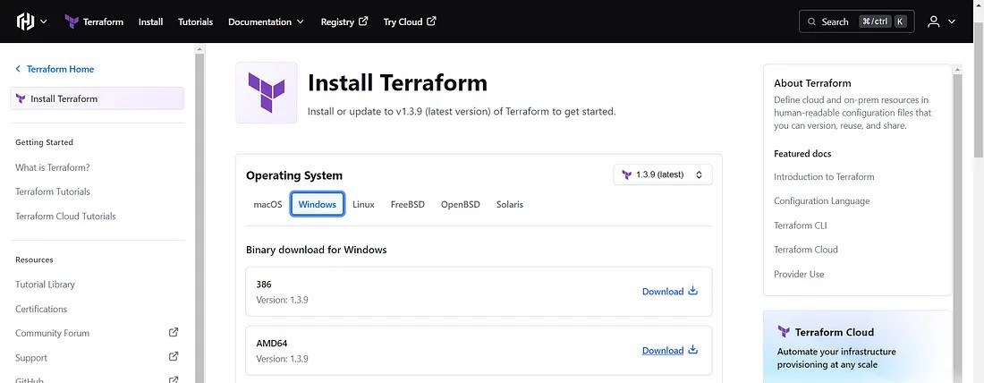

And then select the AMD64 binary for downloading terraform.

Once you click on Download, a zip folder for terraform gets downloaded on the local windows machine.

Unzip the folder and then add the path of your binary to the Environment Variables.

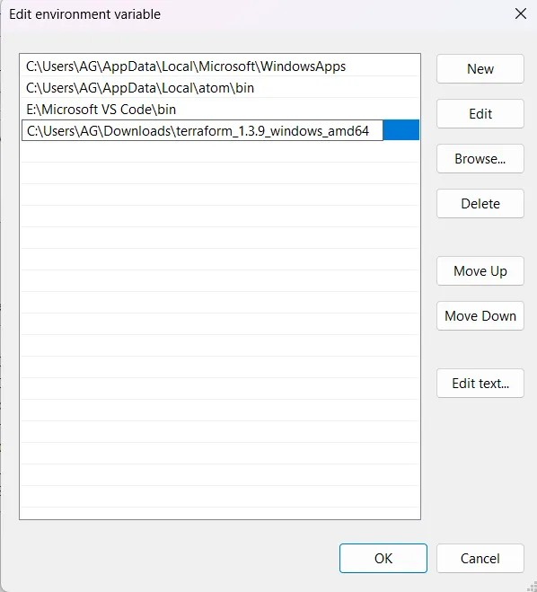

Once done, open the command prompt and check the version of installed terraform by using the command below:

terraform version

1. ***Download and Install AWS-CLI on windows*** Download and run the AWS CLI MSI installer for Windows: <https://awscli.amazonaws.com/AWSCLIV2.msi>

Once done, open the command prompt and check the version of the installed AWS CLI by using the command below:

aws --version

# Create an AWS User with the required permission

Go to your AWS Management Console and in services search for IAM. In the left side panel, select Users. In the Users section, click on Add Users.

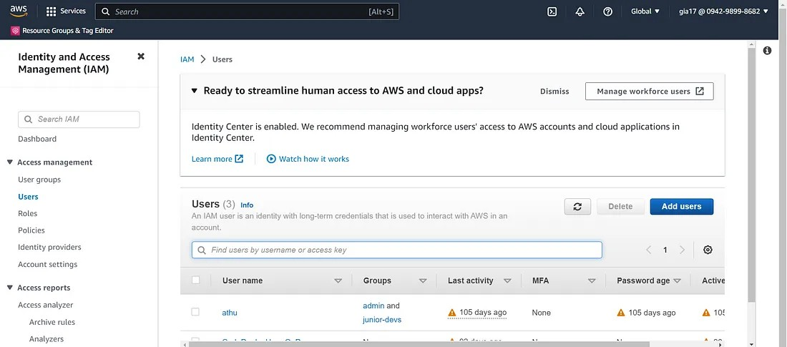

Enter the User name and click Next

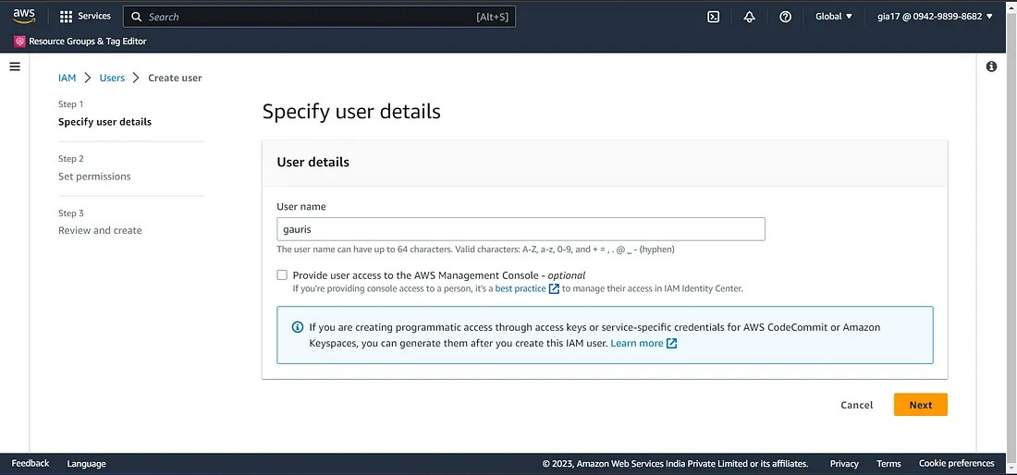

Select Attach policies directly option and select the AdministratorAccess or

AmazonEC2FullAccess and click Next again.

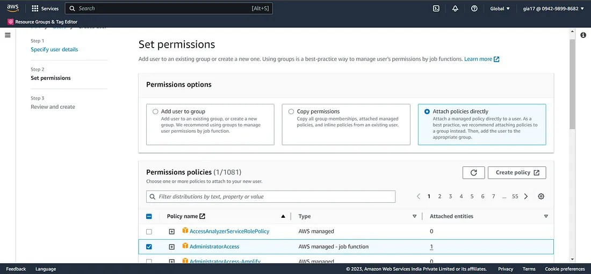

Then Review the User details and click on Create User.

After this, you will see the user created.

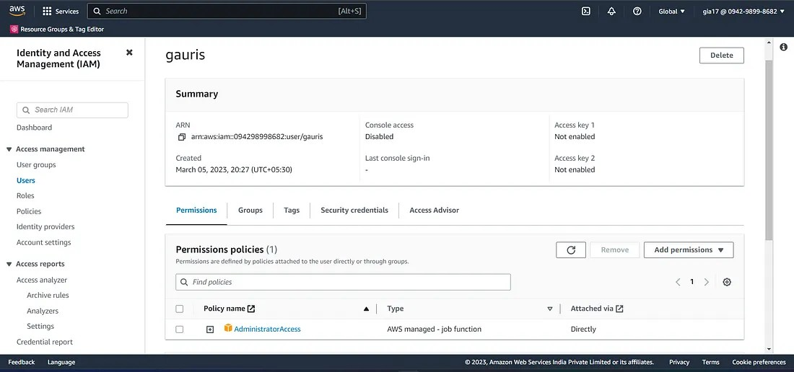

Then within the user select Security credentials.

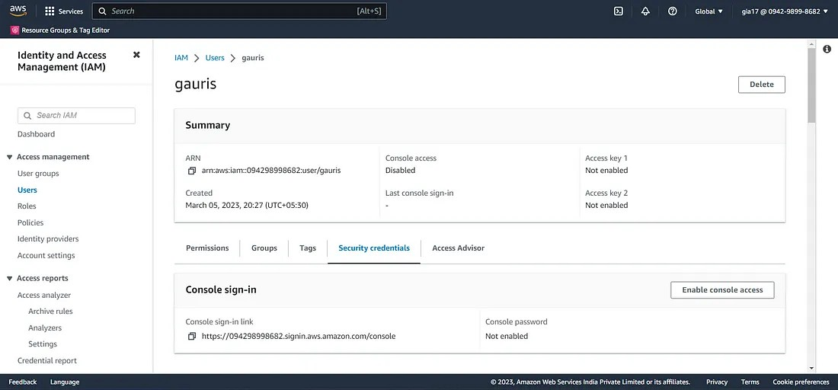

Create an Access Key for the user by selecting the Create access key.

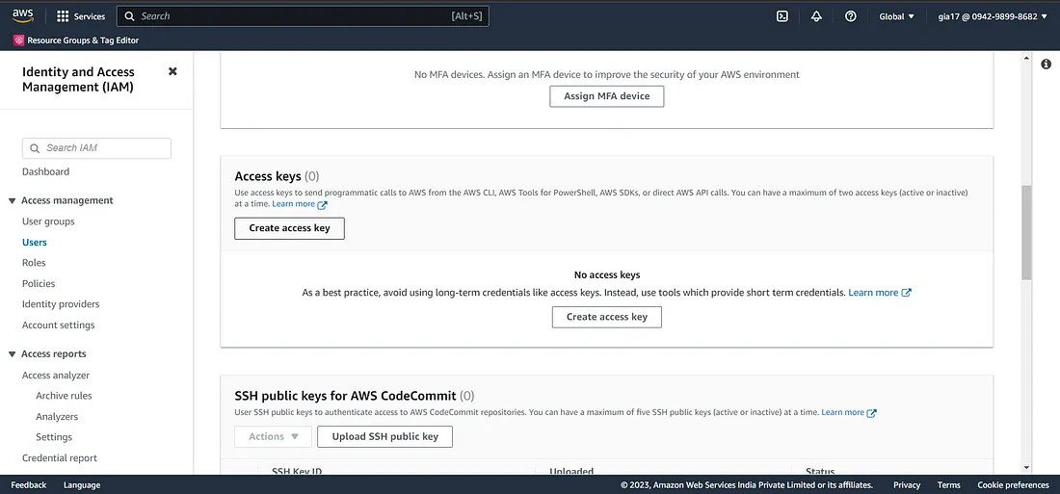

Then select the Command Line Interface (CLI) and click Next.

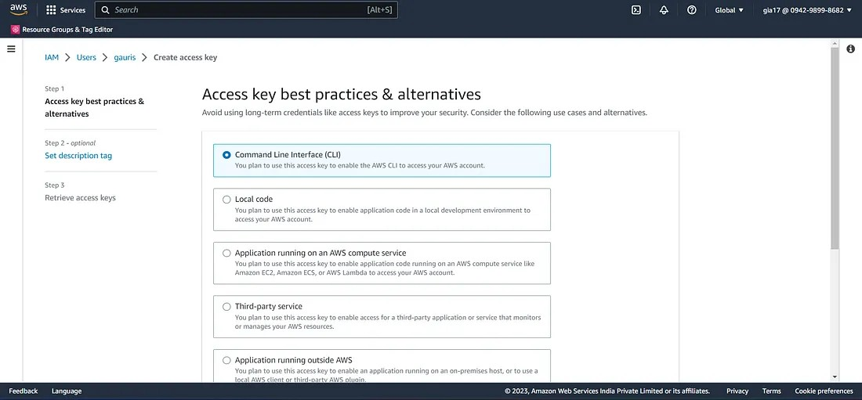

Then Retrieve access keys by downloading the access and secret keys.

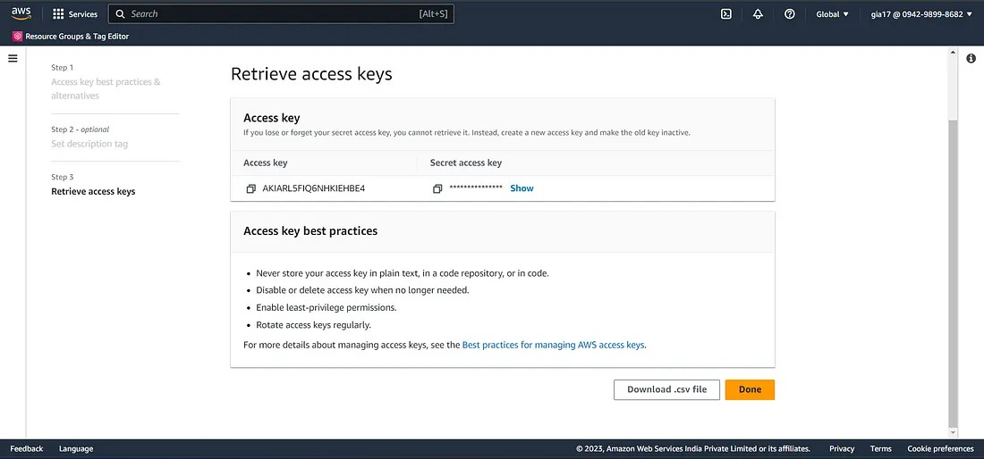

# Configure AWS CLI

Open your Command Prompt and run aws configure

aws configure

It will prompt you to enter the Access and Secret keys along with the region and format.

AWS Access Key ID [None]: <Access Key ID> AWS Secret Access Key [None]: <Secret Key ID> Default region name [None]: <Region>

Default output format [None]: <format>

# Create your terraform configuration file

Create a terraform configuration file with .tf extension in HCL (Hashicorp Configuration Language). For creating an EC2 instance we need to mention the AWS provider in the configuration file. So we first define the provider and then define the resource that is an ec2 instance with required parameters.

provider "aws" { region = "us-east-1"

}

resource "aws_instance" "myInstance" { ami = "ami-006dcf34c09e50022" instance_type = "t2.micro"

tags = {

Name = "MyInstance"

}

}

# Initialize the terraform working directory

Before actually creating the infrastructure we first need to initialize the working directory. This can be done using terraform init command. On running this command, it downloads all the required plugins necessary for building your infrastructure.

terraform init

In order to validate the configuration file run the command below:

terraform validate

# Preview the changes with terraform plan

Once done with the initialization and validation of the configuration file, run the command below to preview the changes before actually implementing them on AWS.

terraform plan

# Creating the infrastructure using terraform apply

Finally, run the command terraform apply to actually deploy the infrastructure on the AWS cloud. This command creates the infrastructure that was previously planned. With this command, terraform.tfstate file gets created which keeps the track of resources created using terraform. This file is by default stored locally, but it can also be stored remotely, which works better in a team environment.

terraform apply

On executing this command it asks for the re-confirmation. Once you enter yes, it implements the desired changes. You can see the instance running in your AWS Management Console after the process of creation is completed.

In this way, we can create an EC2 instance using Terraform.

Hope you found this blog useful. Happy Learning